create table PERSONAL (

per_identidad int primary key,

per_nombre varchar(20) not null,

per_apellidos varchar(20) not null,

per_categoria varchar(15) not null,

per_telefono varchar(10) not null,

per_nacimiento date not null);

create table vehiculo (

veh_placa varchar(6) primary key not null,

veh_tipo varchar(15) not null,

veh_modelo year not null,

veh_estado varchar(10) not null);

create table SALIDA (

sal_codigo int primary key auto_increment,

sal_motivo tinytext not null,

sal_fecha date not null,

sal_hora_salida time not null,

sal_hora_regreso time not null,

sal_costo double(6,2) not null,

veh_placa varchar(6) not null,

foreign key(veh_placa) references vehiculo(veh_placa));

rename table salida to SERVICIOS;

alter table personal add per_direccion varchar(30);

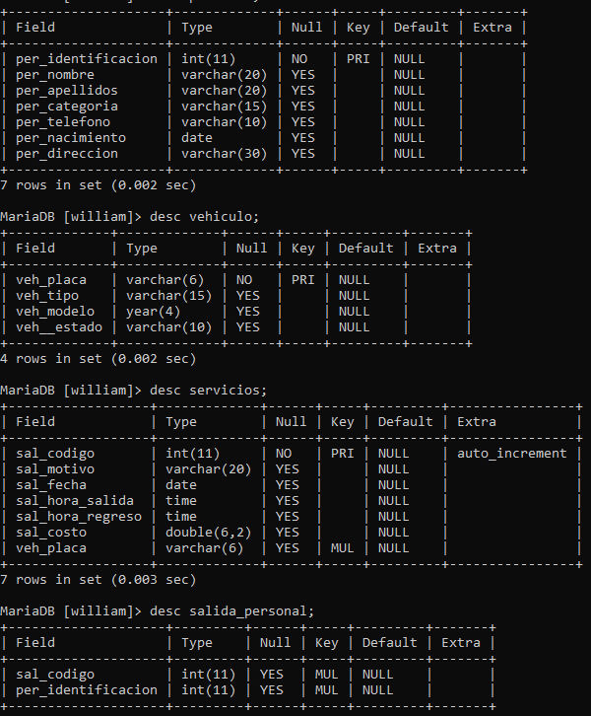

insert into personal values

(35491545, "juan", "perez", "medico", 3103458695, "1979-05-06", "cra 23 #15-23"),

(35454941, "pepito", "jimenez", "conductor", 3202358695, "1984-01-11", "cll 21 #35-13"),

(58454941, "william", "espinel", "paramedico", 3202355789, "1994-01-10", "cll 11 #50-23"),

(87264213, "nicolas", "cifuentes", "enfermera", 3148355789, "1987-10-05", "cra 11 #10-83"),

(59764213, "nicolas", "gomez", "camillero", 3197555789, "1990-12-05", "cra 13 #13-13"),

(59768913, "santiago", "alarcon", "medico", 3197585823, "1991-11-01", "cll 3 #23-18"),

(59128913, "andres", "mena", "medico", 3197585823, "1980-05-11", "cll 10 #23-20"),

(78128913, "andres", "gallo", "conductor", 3297585823, "1979-02-11", "cll 30 #11-21"),

(15628913, "gregorio", "patiño", "paramedico", 3215685823, "1989-12-12", "cra 10 #81-21"),

(16928913, "mario", "gomez", "enfermero", 3278285823, "1987-01-10", "cra 10 #81-21");

insert into vehiculo values

("123zxc", "ambulancia", "1998", "activo"),

("456asd", "carro", "2009", "activo"),

("789qwe", "bus", "1980", "inactivo"),

("123qwe", "ambulancia", "2011", "activo"),

("456zxc", "carro", "2010", "inactivo");

INSERT INTO servicios (sal_motivo, sal_fecha, sal_hora_salida, sal_hora_regreso, sal_costo, veh_placa) VALUES

("URGENCIA", "2024-11-05", "07:17:00", "08:18:00", 1.2,"123zxc"),

("SERVICIO", "2021-11-05", "17:05:59", "18:17:15", 4.2 ,"456asd"),

("EMERGENCIA", "2015-08-21", "05:08:00", "08:09:21", 5.4,"789qwe"),

("EMERGENCIA", "2018-08-21", "19:08:00", "11:09:21", 4.1,"123qwe"),

("SERVICIO", "2001-05-09", "07:05:59", "11:17:05", 2.9,"456zxc"),

("URGENCIA", "1991-03-08", "02:17:50", "05:18:21", 1.2,"123zxc"),

("TRASLADO", "1995-08-30", "02:21:50", "03:25:21", 2.2,"456asd"),

("TRASLADO", "1995-08-30", "13:34:50", "15:25:21", 1.4,"789qwe"),

("URGENCIA", "2013-03-08", "03:35:00", "05:00:21", 1.2,"123qwe"),

("TRASLADO", "2022-06-24", "12:00:54", "15:35:54", 6.1,"456zxc");

insert into salida_personal (sal_codigo, per_identificacion) values

(1, 15628913),

(2, 16928913),

(3, 35454941),

(4, 35491545),

(5, 58454941);

10;

Create view punto10 as select * from personal where per_categoria = "medico" and per_nacimiento between "01-01-1979" and "31-12-1994";

11;

create view punto11 as select *from personal where per_categoria = "enfermero" and per_apellidos = "M%";

12;

create view punto12 as select * from vehiculo where veh_tipo = "ambulancia";

13;

create view punto_13_eval as select * from vehiculo where veh_modelo > 2010 order by veh_tipo asc;

14;

create view punto_14_eval as select vehiculo.veh_placa, vehiculo.veh_tipo, vehiculo.veh_modelo, vehiculo.veh__estado, servicios.sal_hora_regreso from vehiculo

-> inner join servicios on servicios.veh_placa = vehiculo.veh_placa where servicios.sal_hora_regreso >= "18:00:00";

15;

create view punto_15_eval as select personal.per_identificacion, per_nombre, per_apellidos, per_categoria, per_telefono from personal left join salida_personal on personal.per_identificacion = salida_personal.per_identificacion where sal_codigo IS NULL;

16;

delimiter %%

MariaDB [william]> create function fn_costosTipoVehiculo(p_tipoVeh varchar(15))

returns double

begin

declare v_total double(6,2);

select sum(servicios.sal_costo) into v_total from servicios inner join vehiculo on servicios.veh_placa = vehiculo.veh_placa where veh_tipo = "ambulancia";

return v_total;

end%%

Query OK, 0 rows affected (0.003 sec)

MariaDB [william]> delimiter ;

MariaDB [william]> select fn_costosTipoVehiculo("ambulancia");

17;

delimiter %%

create function fn_promediocostos(p_ano1 year, p_ano2 year)

returns double

begin

declare v_total double(6,2);

select avg(servicios.sal_costo) into v_total from servicios inner join vehiculo on servicios.veh_placa = vehiculo.veh_placa where veh_modelo between p_ano1 and p_ano2;

return v_total;

end%%

18;

delimiter %%

create function fn_vehdisponibles()

returns int

begin

declare v_total int;

select count(veh__estado) into v_total from vehiculo where veh__estado = "activo";

return v_total;

end%%

19;

delimiter %%

create function fn_totaldia ()

returns double(6,2)

begin

declare v_total double(6,2);

select sum(sal_costo) into v_total from servicios where sal_fecha = "1995-08-30";

return v_total;

end%%

delimiter ;

20;

delimiter %%

create function fn_costomin ()

returns double(6,2)

begin

declare v_total double(6,2);

select min(sal_costo) into v_total from servicios where sal_fecha = "1995-08-30";

return v_total;

end%%

delimiter ;

21;

DELIMITER $$

CREATE PROCEDURE PA_VEHICULOPORCENTAJE (IN p_tipo VARCHAR(30))

BEGIN

IF p_tipo = "Ambulancia" THEN

Select *, sal_costo * 1.19 as NUEVO_COSTO from servicios inner join vehiculo on vehiculo.veh_placa = servicios.veh_placa where veh_tipo= “ambulancia”;

SELECT "Se realizó un 19% del total actual";

ELSEIF p_tipo = "Carro" THEN

Select *, sal_costo * 1.18 as NUEVO_COSTO from servicios inner join vehiculo on vehiculo.veh_placa = servicios.veh_placa where veh_tipo= “carro”;

SELECT "Se realizó un 18% del total actual";

ELSEIF p_tipo = "Bus" THEN

SELECT "No se ha hecho ningún aumento";

ELSE

SELECT "Tipo de vehículo no registrado";

END IF;

END $$

DELIMITER ;

CALL PA_VEHICULOPORCENTAJE("MOTO");

22;

DELIMITER $$

CREATE PROCEDURE PA_VEHIACTIVO (in p_estado varchar(30))

BEGIN

select servicios.sal_codigo, servicios.sal_motivo, servicios.sal_fecha, servicios.sal_hora_salida,

servicios.sal_hora_regreso, servicios.sal_costo, vehiculo.veh_placa, vehiculo.veh_tipo, vehiculo.veh_modelo, vehiculo.veh__estado

from servicios

inner join vehiculo on servicios.veh_placa = vehiculo.veh_placa

where vehiculo.veh__estado = p_estado;

END $$

DELIMITER ;

call PA_VEHIACTIVO();

23;

DELIMITER $$

CREATE PROCEDURE PA_LISTARSERVICIOSMESACTUAL (IN p_fecha DATE)

BEGIN

SELECT *

FROM servicios

WHERE sal_fecha = p_fecha and sal_costo > 5.0

ORDER BY sal_costo ASC;

END$$

DELIMITER ;

call PA_LISTARSERVICIOSMESACTUAL("2024-11-05");

24;

delimiter %%

create procedure pa_infopersonal(in p_id int)

begin

select personal.per_nombre, personal.per_apellidos, personal.per_categoria, servicios.sal_codigo, servicios.sal_fecha, servicios.sal_hora_salida, servicios.sal_hora_regreso, servicios.sal_costo, servicios.sal_motivo from servicios inner join salida_personal on servicios.sal_codigo = salida_personal.sal_codigo inner join personal on personal.per_identificacion = salida_personal.per_identificacion where personal.per_identificacion = p_id order by servicios.sal_fecha;

end %%

25;

delimiter %%

create procedure pa_costomax(in p_tipopersonal varchar(15))

begin

select max(sal_costo) from servicios inner join salida_personal on salida_personal.sal_codigo = servicios.sal_codigo inner join personal on personal.per_identificacion = salida_personal.per_identificacion where per_categoria = p_tipopersonal;

end %%

26;

DELIMITER $$

CREATE PROCEDURE PA_ELIMINARREGIST ()

BEGIN

DELETE FROM salida_personal WHERE sal_codigo = 3;

END $$

DELIMITER ;

start transaction;

call PA_ELIMINARREGIST();

SELECT * FROM salida_personal;

rollback;

27;

delimiter %%

create procedure pa_cambiarcategoria(in p_nacimiento date)

begin

update personal set per_categoria = "medico" where per_nacimiento < p_nacimiento;

end %%

delimiter ;

start transaction;

call pa_cambiarcategoria("1991-01-01");

select * from personal;

rollback;

28-33;

create user "SUPERADMIN"@"LOCALHOST" identified by "";

Query OK, 0 rows affected (0.002 sec)

MariaDB [(none)]> create user "ANALISTASISTEMA"@"LOCALHOST" identified by "";

Query OK, 0 rows affected (0.001 sec)

MariaDB [(none)]> grant all privileges on eval.* to "SUPERADMIN"@"LOCALHOST";

Query OK, 0 rows affected (0.001 sec)

MariaDB [(none)]> grant SELECT, UPDATE on eval.* to "ANALISTASISTEMAS"@"LOCALHOST";

Query OK, 0 rows affected (0.001 sec)

MariaDB [(none)]> show grants for "SUPERADMIN"@"LOCALHOST";

+--------------------------------------------------------------+

| Grants for SUPERADMIN@localhost |

+--------------------------------------------------------------+

| GRANT USAGE ON *.* TO `SUPERADMIN`@`localhost` |

| GRANT ALL PRIVILEGES ON `eval`.* TO `SUPERADMIN`@`localhost` |

+--------------------------------------------------------------+

2 rows in set (0.000 sec)

MariaDB [(none)]> show grants for "ANALISTASISTEMA"@"LOCALHOST";

+-----------------------------------------------------+

| Grants for ANALISTASISTEMA@localhost |

+-----------------------------------------------------+

| GRANT USAGE ON *.* TO `ANALISTASISTEMA`@`localhost` |

+-----------------------------------------------------+

1 row in set (0.000 sec)

MariaDB [(none)]> RENAME USER "ANALISTASISTEMA"@"LOCALHOST" to "ANALISTA"@"LOCALHOST";

Query OK, 0 rows affected (0.001 sec)

MariaDB [(none)]> revoke all privileges on *.* from "ANALISTA"@"LOCALHOST";

34;

Mysqldump -u root -p William > C:\Users\Ambiente\Desktop\william\eval.sql

Mysql -u root -p william < C:\Users\Ambiente\Desktop\william\eval.sql